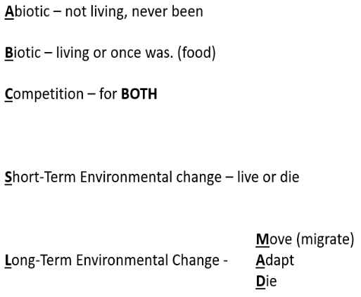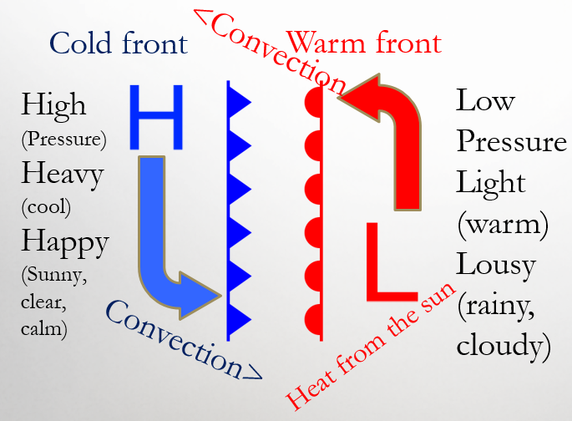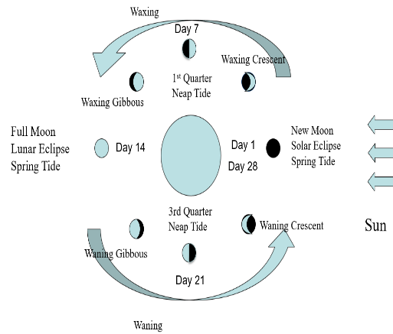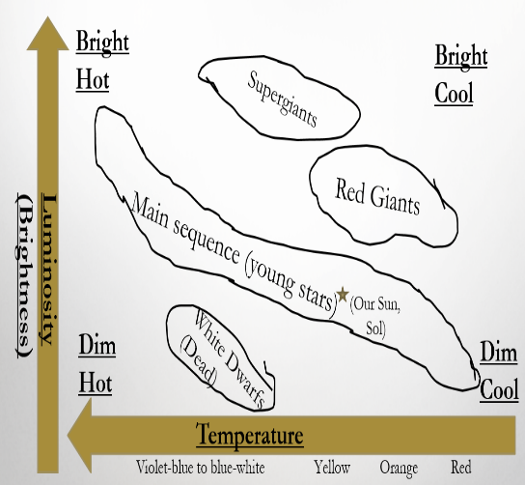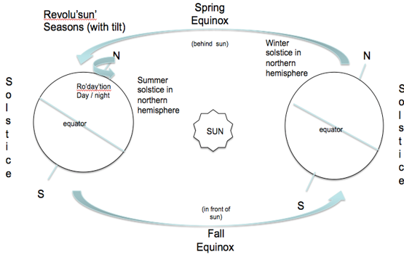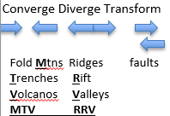

Earth behind sun here

Earth in front of sun here

M mass #

- A atomic #

N Neutrons

**Plates move because unbalanced forces are created by convection in the asthenosphere (upper mantle)**

**I**nertia – 1st law

Objects resist change in motion, so it requires unbalanced force to change

**F**orce, mass, accel

F=ma or acceleration and mass are inversely proportional wt same force

**A**ction – **R**eaction

If one object exerts force on 2nd one, 2nd object exerts same amount in opposite direction

atomic #

**G = gas production**

**E = energy production**

**T = temperature change**

**C = color change**

**O = odor change**

**P = precipitate**

protons

electrons

A = P = e-