**8th Grade Science Unit 5: Tectonics & Mapping Review**

**Multiple Choice**: Write a large capital letter of the best choice in the blank. **Short answer**: Fill in the best answer.

____ 1. The youngest rocks on the ocean floor are located ____.

|  |  |  |  |
| --- | --- | --- | --- |
| a. | near continents | c. | far from mid-ocean ridges |
| b. | at mid-ocean ridges | d. | near Asia |

____ 2. Which of these are found at divergent boundaries?

**F**. continents **H**. trenches

**G**. mid-ocean ridges **J**. mountain ranges

____ 3. The presence of the same ____ on several continents supports the hypothesis of continental drift.

|  |  |  |  |  |  |  |  |
| --- | --- | --- | --- | --- | --- | --- | --- |
| a. | fossils | b. | rock strata | c. | neither a nor b | d. | both a and b |

____ 4. How can we find the likely locations of the plate boundaries on a bathyspheric map?

**F**. by the countries **G**. by the oceans **G**. by the equator **J**. by tracing ‘quakes and volcanoes

____ 5. Plates move away from each other in opposite directions at ____ boundaries.

|  |  |  |  |  |  |  |  |
| --- | --- | --- | --- | --- | --- | --- | --- |
| a. | convergent | b. | stable | c. | divergent | d. | transform |

____ 6. Convergent boundaries are most likely to form which of the following land forms?

**F**. rift valleys **H**. mid-ocean ridges

**G**. folded mountains **J**. strike-slip faults

____ 7. Bands of rock on the seafloor showing alternating magnetic orientation indicate the seafloor further from the mid-ocean rift is _______.

**A**. older **B**. younger **C**. hotter **D**. thinner

8. Fill in the approximate elevation of the following points on the topographic map to the right:

A. _____ B. _____ C. _____ D. _____

 9.

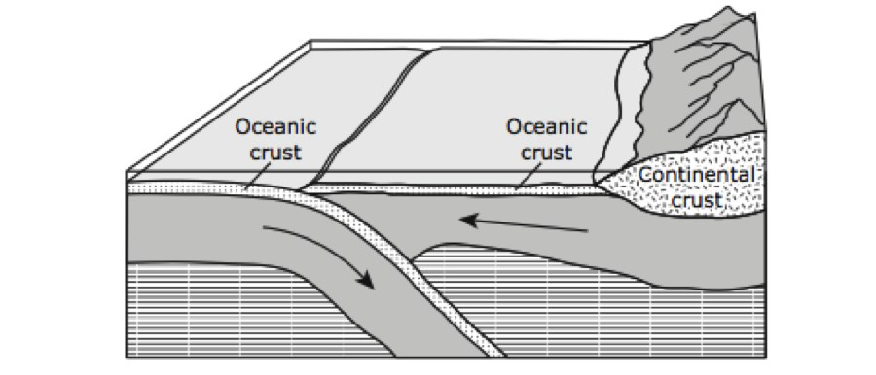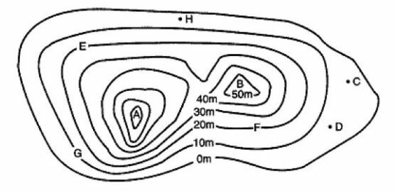

If you walked from point H to point F on the map above, about how much would your elevation change? Bubble in your answer correctly above.

10. Describe what happens when two oceanic plates collide.

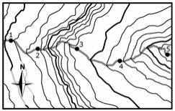 A river is running through a region represented by the topographic map shown here. Use this map to answer the next **THREE** questions.

____ 11. In which portion of the river is steepest? **A**_____

Where will the water flow the slowest? **B**_____ Why?

What do the solid lines mean? **C**_______ _____________

____ 12. If location 1 is a higher elevation than 5, in which direction would you expect the river to run?

**F** North **G** South **H** East **J** West

____ 13. If location 1 is a higher elevation than 5, near what location would you expect a delta to form?

**A** 1 **B**  3 **C**  4 **D**  5 (What’s a delta?)

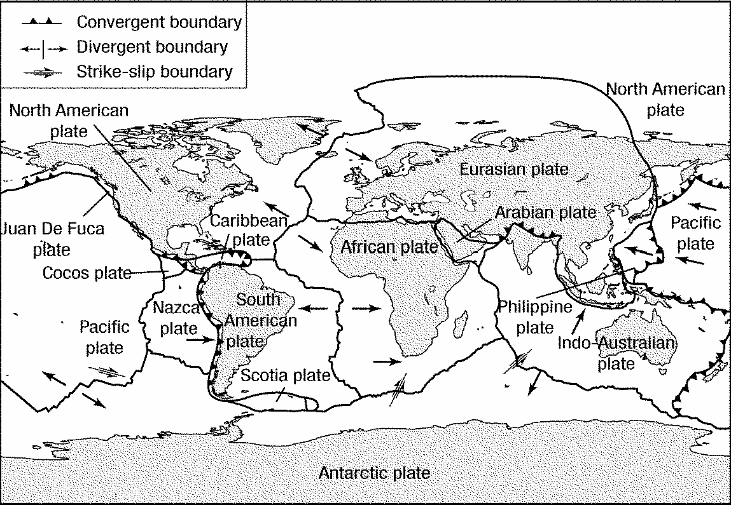

14. The San Andreas fault line crosses through the western united states just south of the Juan De Fuca plate. Draw arrows on the map to the left showing the direction of movement of the land over many, many years that formed this fault.

**Figure 10-1**

____ 15. According to Figure 10-1, what type of plate boundary occurs between the North American Plate and the Eurasian Plate?

**F**. transform boundary **H**. convergent oceanic-continental boundary

**G**. divergent boundary **J**. convergent oceanic-oceanic boundary

____ 16. According to Figure 10-1, what type of relative motion occurs at the mid-ocean ridge between the Nazca Plate and the Pacific Plate?

**A**. Pacific and Nazca plates both going east **C**. Pacific going west, Nazca going east

**B**. Pacific and Nazca plates both going west D. Pacific going east, Nazca going west

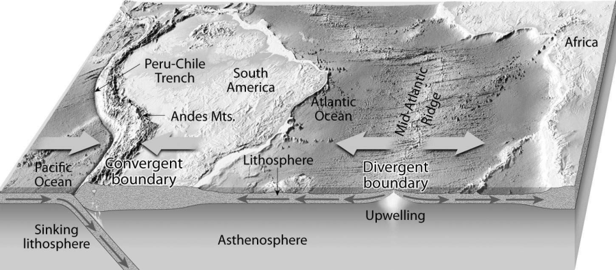____ 17. What is the relationship of the dense oceanic crust that is produced at a divergent plate boundary to the convergence or collision of an oceanic plate and a continental plate, such as the western margin of South America in the diagram below?

**F**. It is more dense than the more buoyant continental crust that it is pulled under

**G**. It is less dense than the less buoyant continental crust that it pushes under

**H**. It has the same density as the continental crust it slams into

**J**. The two have no relationship

____ 18. If rocks on one continent are geologically and chemically exactly the same as rocks from another continent, what does this mean?

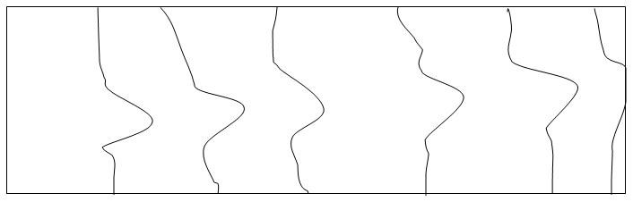

____ 19. On the contour map above, where might a delta form?

|  |  |  |  |  |  |  |  |
| --- | --- | --- | --- | --- | --- | --- | --- |
| a. | to the left | b. | to the right | c. | above | d. | below |

____ 20. If the river in the topographic map illustrated in the previous question cut a deeper canyon over time, what would the topographic map of the area look like?

|  |  |  |  |
| --- | --- | --- | --- |
| **F**. |  | **G**. |  |
| **H**. |  | **J**. |  |

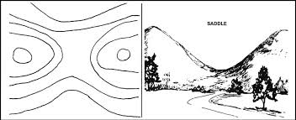

____ 21. If you weathered the formation represented above for a number of years, what would likely happen?

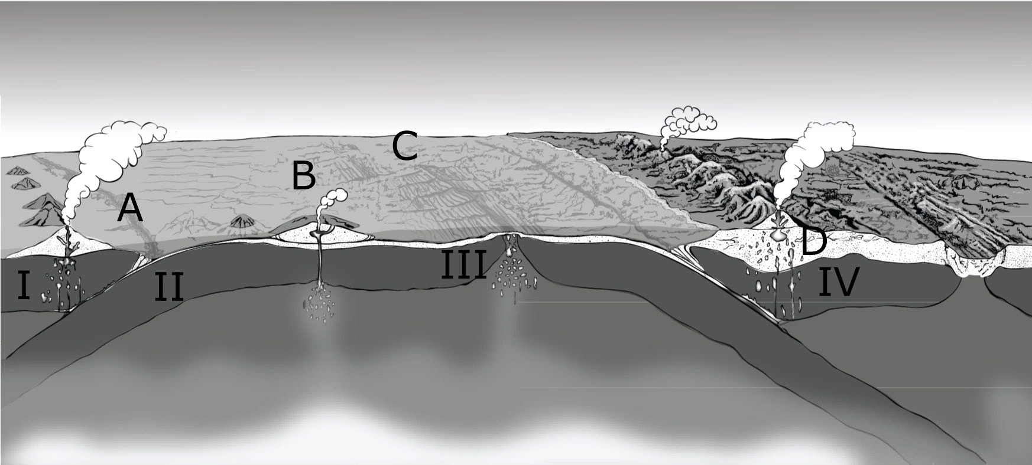

How would this change the contour lines?

22. Where would the oldest ocean floor be found on the figure?

23. What is occurring at point C on the figure to the right?

24. What is occurring at point A on the figure above?

90

50

10

93

25. What will happen over time to a hole, depression or crater like the small one represented on the topographic map to the right if it is in a somewhat flat, arid (dry) area?

**Label the next three pictures with the correct plate boundary name and the landforms created by them.**

26. Boundary: 27. Boundary: 28. Boundary:

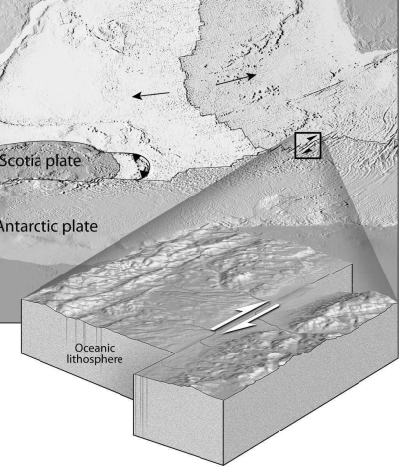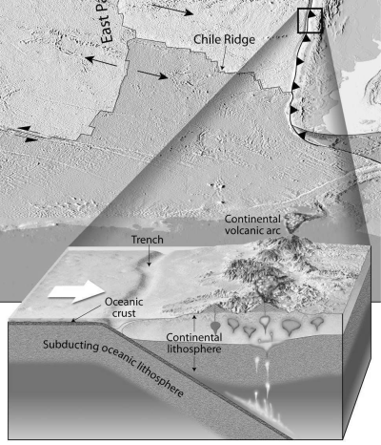

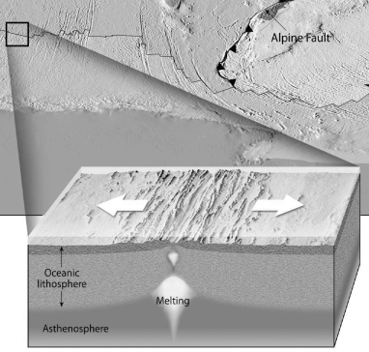

____ 25.

Landforms: Landform: Landform:

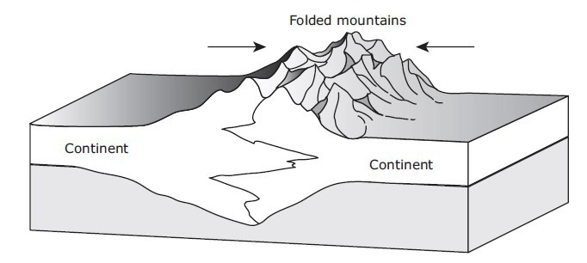29. Describe the process pictured in the image to the right.

30. Alfred Wegener and his theory of continental drift were finally validated when Harry Hess discovered what?

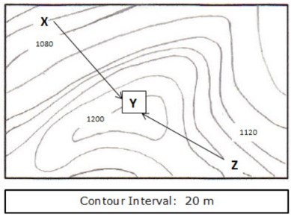31. What new technology or tools made proving this possible?

32. On the topographic map to the right, find the elevation change from point X to point Y. Then find Y to Z.

33. The fact that maps of South America and Africa seem to fit together like puzzle pieces, matching rock strata from widely separated continents and climate evidence support the theory that the continents were once joined. What are two more similar pieces of evidence?

**8th Grade Science Unit 5: Tectonics & Mapping**

**Answer Section (not correct)**

**MULTIPLE CHOICE**

1. ANS: B

2. ANS: B

3. ANS: D PTS: 1 DIF: B OBJ: 2/1

STA: 8.2C | 8.2D | 8.3C | 8.12A | 8.14A

4. ANS: A PTS: 1 DIF: A OBJ: 1/1

STA: 8.3A | 8.3D | 8.12A | 8.14A

5. ANS: C PTS: 1 DIF: B OBJ: 5/3

STA: 8.2C | 8.3 | 8.14A

6. ANS: B PTS: 1 DIF: B OBJ: 2/1

STA: 8.2C | 8.2D | 8.3C | 8.12A | 8.14A

7. ANS: A PTS: 1 DIF: A OBJ: 4/2

STA: 8.3D | 8.7A | 8.12A | 8.14 | 8.14A

8. ANS: B PTS: 1 DIF: B OBJ: 6/3

STA: 8.2C | 8.4A | 8.12A | 8.14A

9. ANS: A PTS: 1 DIF: B OBJ: 7/3

STA: 8.7 | 8.7A | 8.7B | 8.14A

10. ANS: D PTS: 1 DIF: B OBJ: 7/3

STA: 8.7 | 8.7A | 8.7B | 8.14A

11. ANS: B PTS: 1 DIF: B OBJ: 7/3

STA: 8.7 | 8.7A | 8.7B | 8.14A

12. ANS: B PTS: 1 DIF: A OBJ: 5/3

STA: 8.2C | 8.3 | 8.14A

13. ANS: A PTS: 1 DIF: A OBJ: 5/3

STA: 8.2C | 8.3 | 8.14A

14. ANS: A PTS: 1

15. ANS: B PTS: 1

16. ANS: A PTS: 1

17. ANS: B PTS: 1

18. ANS: B PTS: 1

19. ANS: B PTS: 1

20. ANS: C PTS: 1

21. ANS: A PTS: 1

22. ANS: D PTS: 1

**MATCHING**

23. ANS: convergent

24. ANS: transform

25. ANS: divergent