8th Grade Science Topic H Study Guide: Periodic Table

Multiple Choice
Identify the choice that best completes the statement or answers the question.

____ 1. Position of the elements on the periodic table:
a. | allows us to make predictions about their properties.
b. | are determined by atomic mass.
c. | are in order of their discovery.
d. | all of the above are true.
____ 2. Demetri Mendeleev, a Russian scientist, established the first really useful periodic table. His table was much more useful than others before it because:
a. | it left gaps where undiscovered elements should be.
b. | arranged by properties
c. | peer reviewed using scientific method
d. | all of the above are true.
3. Vertical (up and down) columns on the periodic table are called:

4. Horizontal (left to right) rows on the periodic table are called:

5. Group 1 (1A) elements have a special name. They are called:
6. Group 2 (2A) elements have a special name. They are called:
____ 7. Group I elements share certain properties. These include:
a. | Silvery in color | b. | Very malleable | c. | very reactive to water | d. | All the above

8. Groups 3-12 (1B-8B) elements include most of the metals we think of when we think of what metals are. However, they are not as predictable as group 1 and 2 metals. What do we call the elements in groups 3-12?
9. Groups 13-16 (3A – 6A) elements are split in a stair step pattern. Elements bordering this line are:

10. Group 17 (7A) elements are called:

11. Group 8A (group 18) elements are called:
____ 12. Group 17 elements share many of the same properties, like other groups. These properties include:
a. | Form salts | b. | Non-metals | c. | Corrosive | d. | All of these

____ 13. Group 8A elements share many of the same properties, like other groups. These properties include:
a. | Form gasses | b. | Non-metallic | c. | Unreactive | d. | All of these

____ 14. The noble gases, such as helium and xenon, are non-reactive because:
a. | they have completely filled outer electron shells.
b. | they are chemically unstable.
c. | they are unusually large atoms.
d. | they are in the same family as Krypton, which can kill even Superman.
____ 15. Chlorine, element number 17, is located in the third row and the next-to-the-last group of the periodic table. How many electron shells would be completely filled by a neutral atom of chlorine? How many electrons would be left over?
a. | 1 shell filled, 7 electrons left over | c. | 2 shells filled, 7 electrons left over
b. | 1 shell filled, 1 electron left over | d. | 2 shells filled, 1 electron left over
____ 16. Fluorine, element number 9, is located in the second row and the next-to-the-last group of the periodic table. How many electron shells would be completely filled by a neutral atom of flourine? How many electrons would be left over?
a. | 1 shell filled, 7 electrons left over | c. | 2 shells filled, 7 electrons left over
b. | 1 shell filled, 1 electron left over | d. | 2 shells filled, 1 electron left over
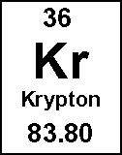
____ 17. Elements in the same column on the periodic table have similar chemical reactivity because:
____ 18. When Mendeleev published his periodic table, there were some spaces for undiscovered elements. Figure 3-1 is a section of a similar table. A reasonable value for the atomic mass of the missing element is ____.
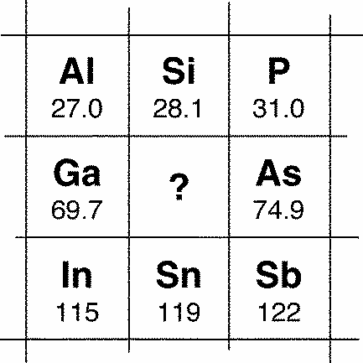
a. | 101 b. 72.3 | c. | 68.2 d. 34.8
19. Every element has its own atomic number. The atomic number is the number of ____ in the nucleus of an atom of the element.
20. In the modern periodic table, elements are arranged according to increasing ____.
____ 21. Which of the following elements is most similar to carbon?
a. Boron b. Dioxide c. Nitrogen d. Silicon
____ 22. Comparing metals to non-metals in the same period, metals tend to have:
a. Lower atomic mass b. More electrons c. More neutrons d. more reactivity
23. Name 3 properties of metals.

24. What makes each element glow with its own specific color in the flame test?

25. What is the most important reason summer is warmer than winter across most of the Earth?

____ 26. Which of the following traits do calcium and selenium have in common?
a. Atomic number b. Atomic mass c. Energy levels d. Valence electrons

27. Sodium reacts with chlorine in a 1:1 ratio to form NaCl. What ratio would lithium react with chlorine?

28. In the Venn diagram below, what element is element I?
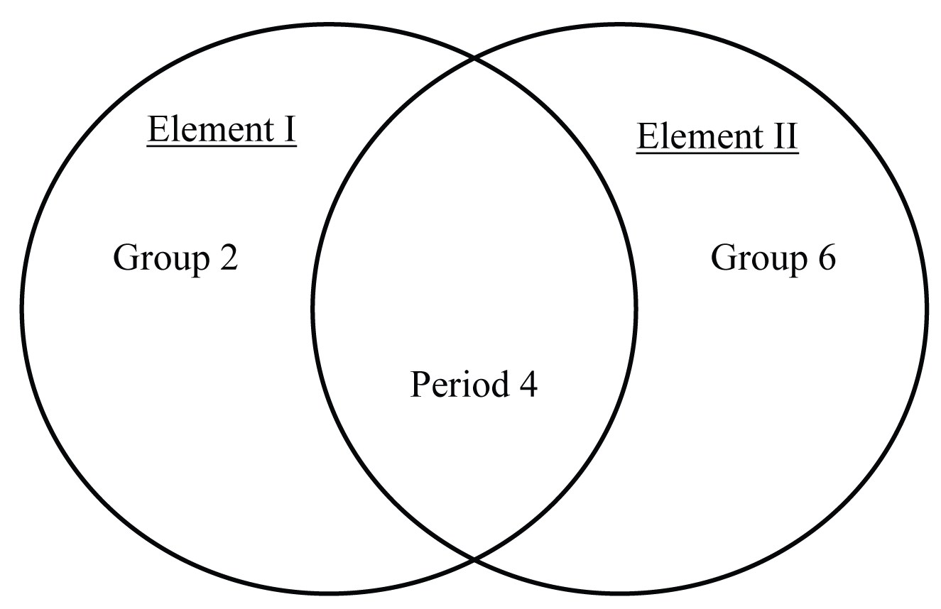

Using your periodic table primer, fill in the empty cells in the table below. The first row is an example.
 | Element | # Energy Levels  (Shells, Rings) | # Valence Electrons | Group Name | Metal,  Non-metal, or Metalloid | Element with Similar Properties
 | Mg | 3 | 2 | Alkali Earth | Metal | Be
29. | Cl
30. |  | 5 | 8
31. |  |  | 4 |  | Non-Metal | Si
32. | K

33. The drums of photocopy machines contains an element that is shiny, but brittle and only conducts electricity when exposed to an electrical current. What family would this element most likely belong to?
a. metal b. metalloid c. non-metal d. lanthanoid
34. An element forms chalky white compounds, but when pure it can be cut with a butter-knife, showing a shiny surface that can conduct heat and electricity. What family would this element most likely belong to?
a. metal b. metalloid c. non-metal d. lanthanoid
35. Your turn. Now you describe some properties of an element that would make it fit the non-metal family.

36. What can you say about elements near each other in the same period?

37. What 2 properties usually (or always) increase as you move left to right across a period?

38. Find the elevation change from X to Z. 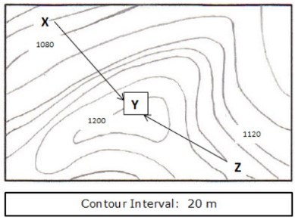

39.
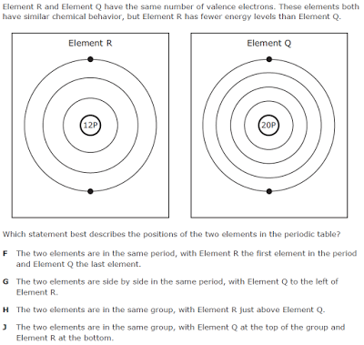
40.
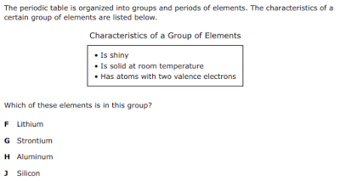
41.
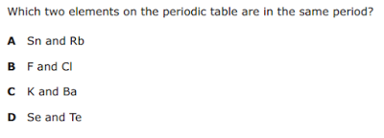
42. Students in a science class prepared flash cards so that they could quiz one another about the arrangement of the periodic table. One of the flash cards contained information about two elements, Element L and Element M.
The students had to use the information on the flash card to determine possible positions of the two elements on a blank periodic table. Which periodic table has the elements placed in locations that match the information on the flash card?
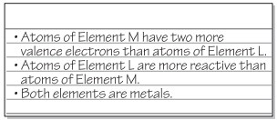
A. 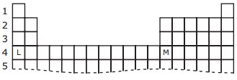
B. 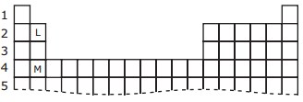
C. 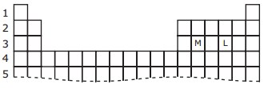
D. 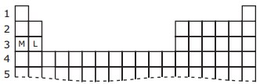

43.
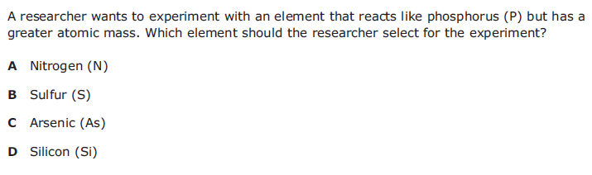

44. A student is studying the ways different elements are similar to one another. Diagrams of atoms from four different elements are shown below. 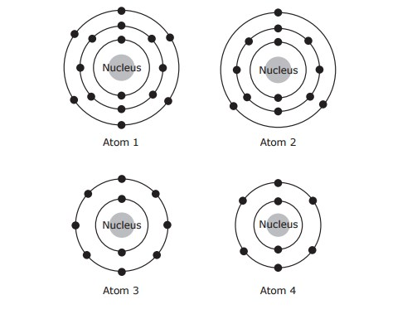
Which two atoms are of elements in the same group in the periodic table?
A Atom 1 and Atom 2 B Atom 1 and Atom 4
C Atom 2 and Atom 3 D Atom 3 and Atom 4

45. The model of the periodic table below shows the locations of four elements.
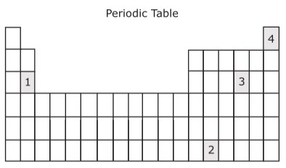
A student is asked to identify an element that is a pale-yellow brittle solid and does not conduct electricity. At which location in this periodic table would the element most likely be found?
A 1 B 2 C 3 D 4

46.
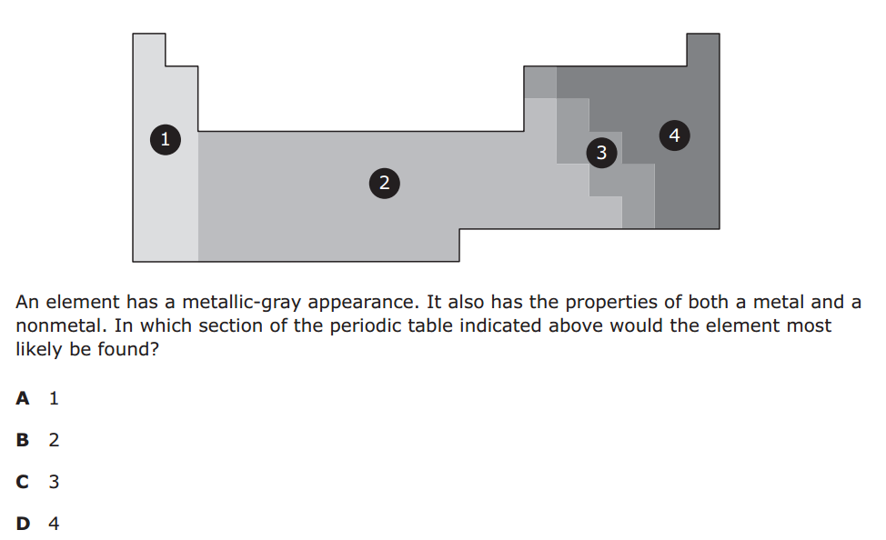

47.
