Review Topic J

1. How much force is needed to accelerate a 7.1 kg skier at 4 m/s/s?

2. What is the velocity of a car moving if it moves downward 12.4 meters in 6.2 seconds?

3. What is the acceleration of a 0.075 kg when a 12 N force is applied?

4. A student pushes a 0.33 kg toy car with a force of 6 N. What is the car’s acceleration?

5. How much force is needed for John to make the .2 kg soccer ball accelerate at 4 m/s/s?

6. How fast is the fish swimming if the fish is moving 10 meters in 4.5 seconds?

7. What is the mass of the biker and bike if there is an acceleration of 7.9 m/s/s and a 440 N force?

8 The 1.6 kg car has a 3 N force on it. Which expression would be used to calculate the acceleration?

- 1.6 kg b. 1.6 kg * 3N
3N

c. 3 N - 1.6 kg d. 3N
1.6 kg

9. How much force is needed for three guys to push a car weighing 84.2 kg to move 2.5 m/s/s?

10. How fast will Jenna’s corvette travel if it is moving at 65.2 miles for 3.5 hours?

11. A basketball with a mass of 0.60 kg is accelerated with a force of 10.8 N. If resisting forces are ignored, what is the acceleration of the basketball to the nearest m/s²?

12. When a space shuttle was launched, the astronauts onboard experienced an acceleration of 29.0 m/s². If one of the astronauts had a mass of 60.0 kg, what net force in newtons did the astronaut experience?

13. The diagram show a homemade car being pushed with a force of 25 N.
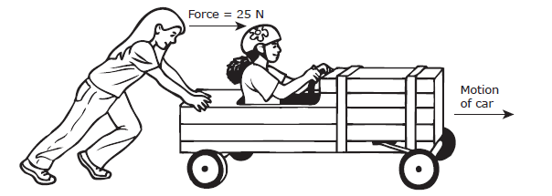
The force causes the car to move at a constant speed of 3 m/s. What will happen if the force is changed to 35 N?
F. The car will move at a constant speed of 13 m/s H. The speed of the car will increase.
G. The speed of the car will not change. J. The speed of the car will decrease to 1 m/s.

14. Two people are pushing the table as shown above.
What is the net force and which way will the table move?

15.
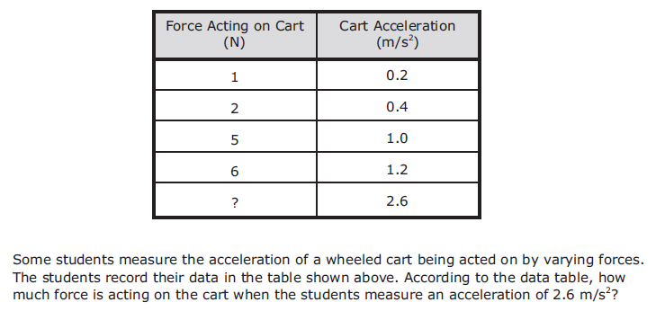
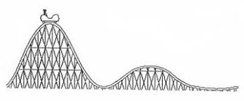
A B C D E F G H
16. Where are there unbalanced forces on the car as it moves along the roller coaster?

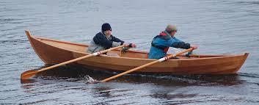
- m = 125 kg B. m= 100 kg C. m = 160 kg

17. Which boat has the greatest change in speed if the applied force is the same?

18. A golfer hits a 0.045 kg golf ball so that it accelerates at 1500 m/s².

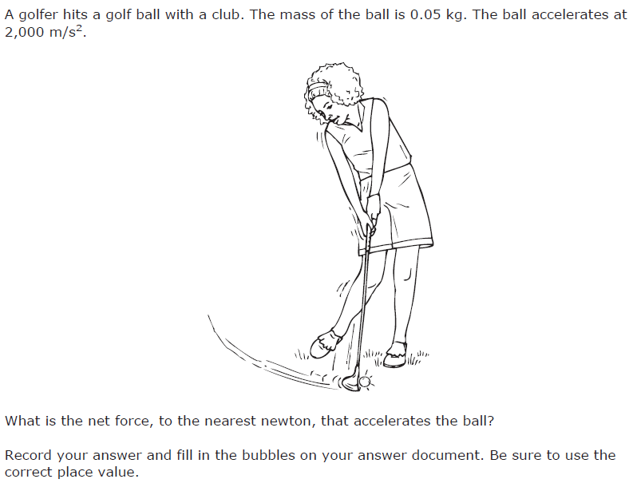
What is the force on the golf ball?

19. A meteor moving 468 km per minute traveling in a south-to-north direction passed near Earth in 2013. Because the meteor was only 45 m wide and was 27,700 km above Earth’s surface, it was not visible without the aid of a telescope. Which statement describes the meteor’s motion?

A Its velocity was 7.8 km/s northward.
B Its acceleration was 468 km/s2.
C Its speed was 468 km/s northward.
D Its acceleration was 7.8 km/s2.

20. A leaf fell from a tree branch. Which of these best describes why the leaf fell in a crooked path instead of straight down?

A Objects with irregular shapes never fall in straight lines.
B Air currents and gravity applied changing and unbalanced forces to the leaf.
C The upward force of the air on the leaf was greater than the downward force of gravity.
D Once the leaf was in motion, it continued moving in the same direction because the forces were balanced.

21 Put the words and phrases with the correct category Balanced Forces Unbalanced Forces

Book falls off desk Speed increasing
Constant speed Speed decreasing
Pencil sitting on desk Going downhill
Car slowing down Going uphill
Friction causes the sphere to stop rolling Gravity pulls down and table pushes up

22. Match the type of equipment with the type of measurement.
- Meter stick A. Force
- Balance B. Direction
- Spring scale C. Mass
- Timer D. Distance
- Compass E. Time

23. Label the phrases with the correct category. Speed Velocity Acceleration Change in distance over time Change in velocity over time_______________
Has direction associated with it No specific direction_____________________ Change in speed over time Change in distance over time_______________

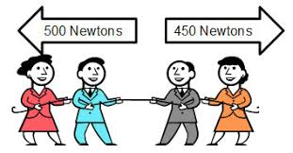
24. Which way will the people go if two more people pulling with a force of 100 N join the team on the right.

25. Where are the forces balanced on the car
as it moves along the roller coaster?

A B C D E F G H
26. Speed Velocity Acceleration
Label the words and phrases with the correct category
66 m/s moving faster stopped 99 m/s/s
2.54 km/hr upward move to the west
27. A toy train engine rests motionless on a track. One student begins pushing the engine to the right with a force of 2 N. At the same time, another student begins pushing the engine to the left with a force of 5 N. Which of the following best describes the resulting motion of the engine?
- It travels left at a constant speed.
- It travels left at an increasing speed.
- It travels right at a constant speed.
- It travels right at an increasing speed.

28. The three vehicles shown below are all traveling at a speed of 15 m/s, but only the pickup truck has a changing velocity.
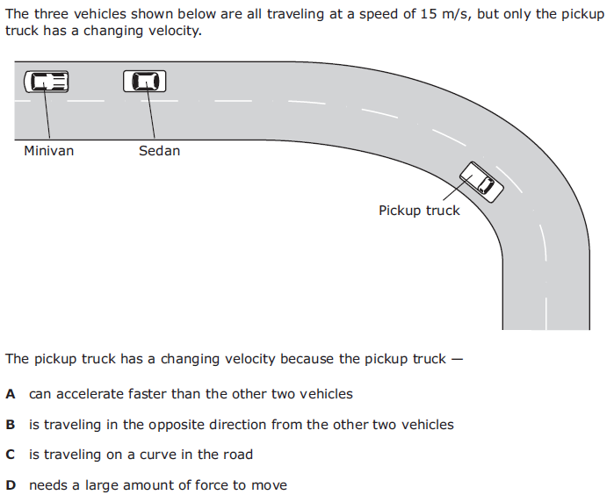
The pickup truck has a changing velocity because the pickup truck --
- can accelerate faster than the other two vehicles
- is traveling to the opposite direction from the other two vehicles
- is traveling on a curve in the road
- needs a large amount of force to move.

29. A student graphed the position of a car during a 7-second time interval.

Which statement best describes the cart?
F. The cart was stationary with a velocity of 0 m/s for the entire 7 seconds.
G. The car was stationary except for a short burst of acceleration of 0.5 m/s².
H. The cart moved at a constant velocity of 0.5 m/s for the entire 7 seconds.
J. The cart accelerated at a constant rate of approximately 0.8 m/s².

30. Which of the following best describes the velocity of an object?
- 30 m/s C. 30 m/s east
- 30 m east D 30 m/s²

