Period:
Isaac Newton’s 3 Laws of Motion

Sir Isaac Newton (1642-1727) was an English physicist and mathematician. Before the age of 30 he formulated the laws of motion and invented calculus. Much of our modern science is based on Newton’s

Law One – Law of Inertia
An object at rest will stay at rest unless
acted on by an unbalance force. An object in motion will stay
in motion unless acted upon by an unbalanced force.
OR
Things keep moving or stay at rest, unless a net force acts upon them.
Newton’s Laws of Motion

Law Two – F = ma
The acceleration of an object is propor-
tional to the force acting on it
and inversely proportional to its mass.

OR

Force causes acceleration, while mass resists acceleration

Law Three –
Law of Equal and Opposite Forces.
Whenever one object exerts a force on
another object, the second exert an equal and opposite force on the first.
OR
For every action there is an equal and opposite reaction.

Inertia
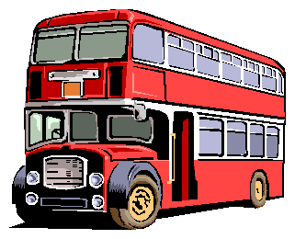

Inertia is the property of an object that resists change of motion.
Force
A force is any action that can change or cause motion.
A force is any push or pull.
We use Newtons (N) to measure force.

Moving objects have inertia: they want to keep moving; stopped objects have inertia:
More mass,
more inertia

Net Force Net force is the sum of all the forces and has direction.
(Be sure to make right positive and left negative.)

they want to stay at rest.
More mass = more inertia! Something that is harder
to push has more inertia!

Less mass, less inertia
An object will move in the direction of the net (or unbalanced) force.
- 400 N + 200 N

Net Force = + 200 N – 400 N = – 200 N (left)
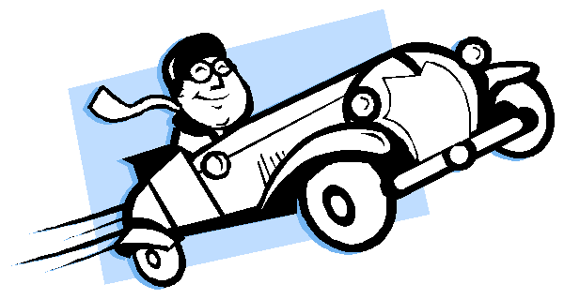

Force
Newton’s Second Law

Mass
(in kg)
F = ma

F = ma tells us:
For the same acceleration,
more mass requires more force.

(in Newtons)
Acceleration
(in m/sec2)
For the same mass,
more acceleration
Newton’s 2nd Law tells us that when
you accelerate (stomp on the gas) or decelerate quickly (brake fast) you use

Force equals mass times acceleration.

Ex. How big a force does it take to give a
50 kg object an acceleration of 40 m/s2.
requires more force.

Ex. If a 50 N force pulls on a
10 kg object, how much acceleration will occur?
more force and wear out engine parts and brakes faster.

Ex. A force of 49 N causes a 7 m/s2 acceleration. Find the mass of the object it was pulling.

Variables:
40 m/s2 = a
Solve:

F = ma
Variables:
50 N = F
Solve:
F = m a
Variables:
49 N = F
Solve:

F = m a

50 kg = m
F = ?
F = 50(40) F = 50 x 40
10 kg = m a = ?
5 0 = 1 0 a
5 0 = 1 0 a
7 m/s2= a m = ?
4 9 = m 7
4 9 = m 7

Equation:
F = 2000N
Equation:
1 0 1 0
Equation: 7 7

F = ma
F = ma
a = 5 m /s 2
F = ma
m = 7 k g

Period:
1. F =

2. m =

3. a =

4. s =

5. d =

125 kilograms

6 Newtons
3 m/s2

29 meters/sec

228 meters

Which of Newton’s Three Laws Applies?
Law 1, 2, or 3?

When you put a book on a table the table pushes on the book.

A person is pushed forward into their seatbelt when a car stops.

A larger car takes more force to move.

1. Inertia

2. Mass
A. An action that can change motion.

B. Accelerates all objects toward the center of the Earth
A person leans on a wall and the wall pushes back.

A brick sits on a table until you push on it.

3. Gravity

4. Net force

C. The amount of matter in an object

D. Total of all of the forces on an object.

Understanding Net Force
Which way will it accelerate?

5. Force

E. Ability of an object to resist change of motion.

30 N

M 25 N

Number these from least (1) to most (5) inertia.

A baseball A small car

A truck A feather A large train
6 N

M 8 N

Number these from least (1) to most (5) force sideways.

Fast car Parked truck

Slow car Fast baseball

Fast feather
15 N
M 15 N

A sled is being pulled to the left by 5 dogs, each dog pulling with
6 Newtons of force. Find the net force.
A 20 kg bike accelerates at 10 m/s2. With what force was the person pedaling?

If a person pulls on a cart to the right with a force of 10 N and a second person pulls to the left with a force of 3 N, what is the net force (+ direction) on the cart?
If a person is pushing a cart with a force of 40 Newtons and it accelerates at 0.5 m/s2, what is the mass of the cart?

A 2 N and 6 N force pull on an object to the right and a 4 N force pulls to the left a 0.5 kg object. What is the net force on the object? What is the acceleration of the object?
What is the acceleration of a 3 kg rock that is thrown with a force of 18 N?

