Spring 2020 Dual Credit Hold Information Packet
The attached packet provide instructions on how to login to your CougarWeb, view your holds, and remove common dual credit registration holds

- Check your CougarWeb for holds
- Remove your registration holds ASAP
  - Contact Ms. Wilson, sswilson@collin.edu for further assistance on removing any possible holds
- Turn the attached HS Permission Form ASAP, to Ms. Shutt or Ms. Pennell, GB Academy, Room A113

How to log in to your CougarWeb
- Go to the website; www.collin.edu

- Click on “COUGARWEB LOGIN” 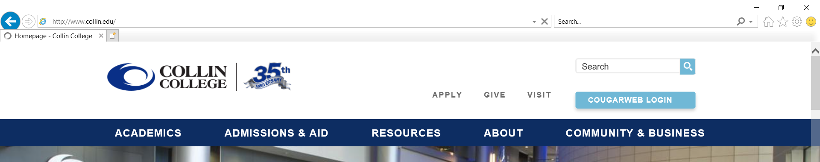

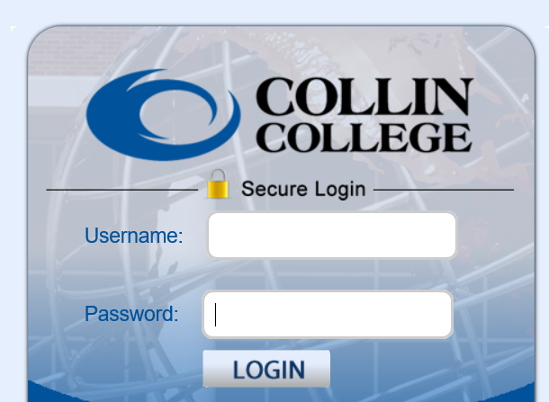
- Sign in to CougarWeb, using your CougarWeb username and password

  - Your CougarWeb login information was emailed to you, after you completed your Collin application
  - CougarWeb Username: first part of your Collin email, before the “@” sign
  - CougarWeb Password: the last 6 digits of your CWID

- If you are not able to find your CougarWeb login information, please email sswilson@collin.edu, with your first name, last name, and birth date.

How to View Your Holds

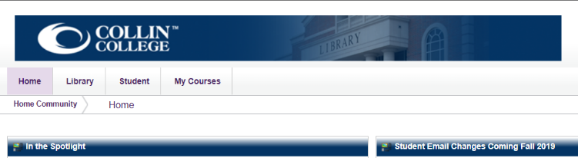
- Click on the “Student” tab

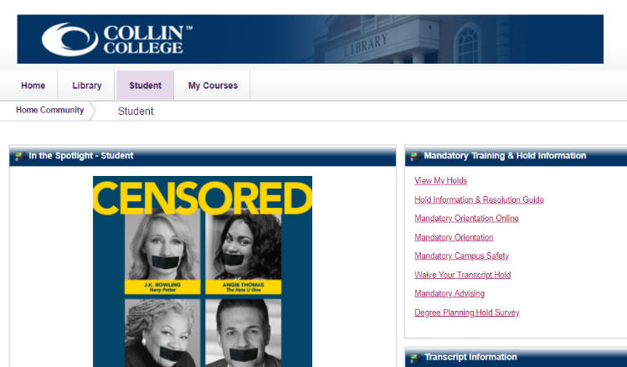
- Under “Mandatory Training & Hold Information” click on “View My Holds”

- Click on “Holds and Registration Status”

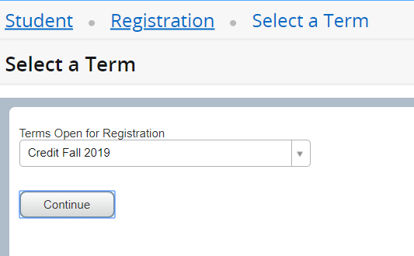
- Under the drop down menu click on “Credit Fall 2019”

Common Holds
To view holds log into CougarWeb (collin.edu) and click on Student Tab located at the top, then click on VIEW MY HOLDS. Below are common holds and steps to resolve.

High School Enrollment Form: Students and parents must obtain a high school enrollment form for every semester a student is taking dual credit. The high school enrollment form is located on the PDF posted here. The CTE Counselor and the CTE Administrative Secretary can sign off on the high school permission form. Students wanting to take concurrent (college only) courses are still required by state law to fill out a form for the classes they are wanting to take. Forms can also be picked up and dropped off at the Dr. Gene Burton College & Career Academy Career Center A113.

Mandatory Advising Holds: This is a quick survey students complete online in their CougarWeb portal. After submitting the survey, the hold will remove itself with in the hour. Log into CougarWeb> Click on Student Tab>Click on Mandatory Advising link> Complete form and submit.

Social Security Hold: Students who did not enter their Social Security number on their initial Collin Application will have this hold. Log into CougarWeb> Click on Studen Tab> located in the right hand upper corner click STUDENT TAX ID> fill out form and submit. Hold will remove automatically.

Immunization Proof Required - Students taking dual credit classes through Rockwall ISD at the Burton campus only need to sign the Bacterial Exemption waiver form that was provided in their dual credit packet. Immunization records are only required for students taking college classes on the Collin College campuses.

TSI hold- Students must provide TSI exemption or waiver scores or take the TSI test. Please refer to the TSI tab for further information. TSI Webpage . If your student has provided TSI exemptions, waivers, or TSI scores and has not met the math criteria the student will have a TSI hold for their spring semester of their senior year. Contact Collin College's Dual Credit office for assistance: DualCredit@collin.edu ph. 469-365-1850

How to clear “Mandatory Advising” hold.

- Click on the “Student” tab

- Under “Mandatory Training & Hold Information” click on “Mandatory Advising”

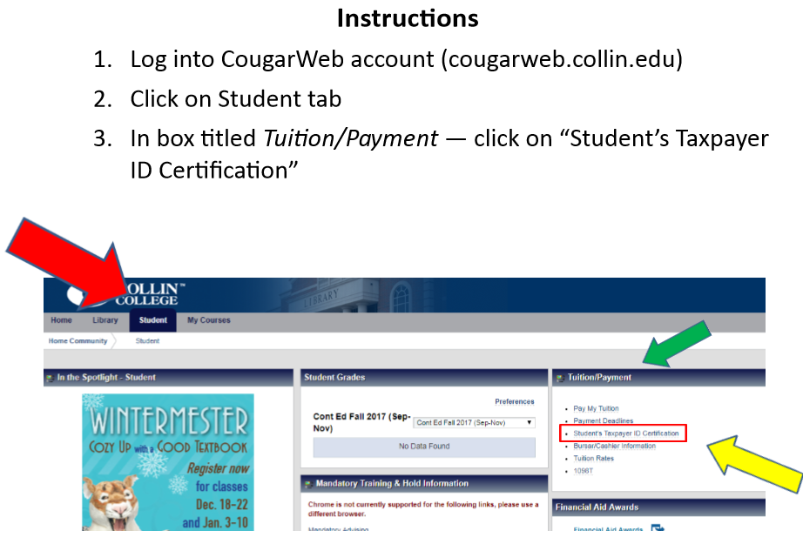
How to Clear SSN Hold

