Rockwall Yellowjacket Tennis Camp 2023
May 30-June 2^{nd_}
Ages 5-6 8:30am-9:45am
Ages 7-11 8:30-1O:30am
Ages 12-14 10:30am-12:30pm
Where: Wilkerson Sanders  Cost: $75.00  2 family members $115.00  3 family members 155.00 4+ 195.00 | Make Checks Payable to: RHS  Yellowjacket Tennis Camp  Registration Due May 26, 2023  Walk Up Fee $85.00 | Mail Registration to Att:  Lana Fulkerson  901 Yellowjacket lane Rockwall Tx 75087  If you have any questions please contact me  lana.fulkerson@rockwallisd.org
- Scholarships available by contacting lana.fulkerson@rockwallisd.org
- Campers-bring water bottle, hat, racquet if you have (we have them if needed)-
wear cool comfortable clothing and tennis shoes
- SportsYou will be used for RainOut/Weather delays, camp pictures,and further tennis info we will use -It is a very easy App to download The Code to join is 5WNV-CFWP
________________________________________________________________________________

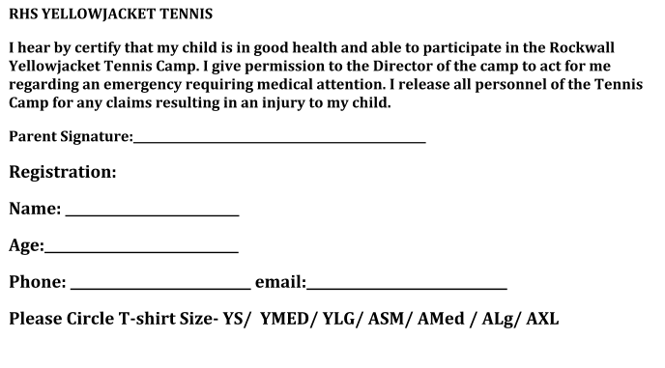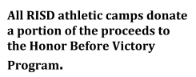
School attended and grade finished _______/ Please check off if your child has ever had any tennis instruction prior to camp: __ yes ____ no ____ played with family and friends

